IB ESS is designed to be a two year course. This requires some topics to be covered on your own before the test in May. Below are several topics, with their teacher notes, that we may not cover before the test and you are HIGHLY encouraged to cover on your own with the OX textbook, additional research, and the SBS textbook.

In addition to the topics listed below, please see the full syllabus to review needed areas. Reviewing ecology and conservation are suggested areas to start.

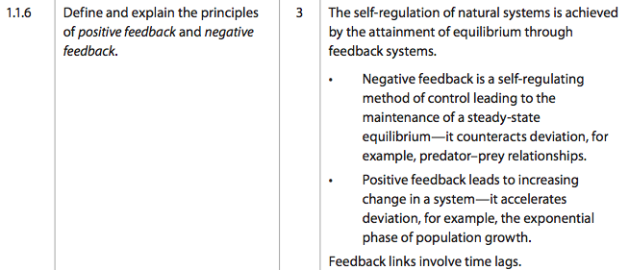

Sucession, Diversity, and Environmental Change

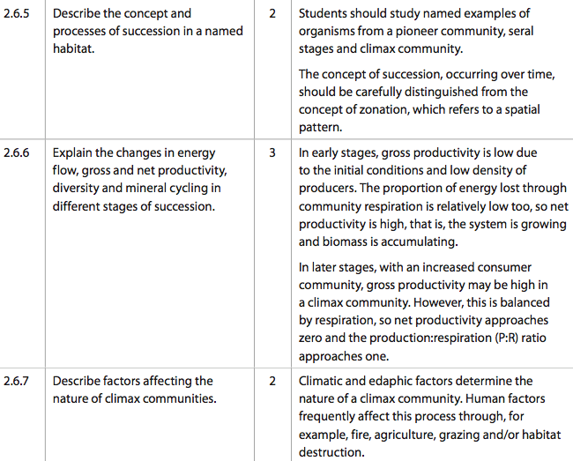
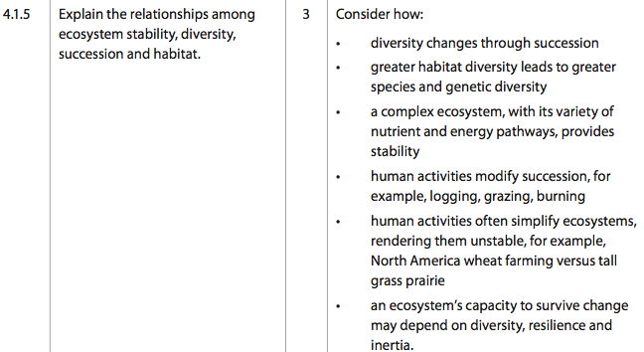

Pollution & Monitoring

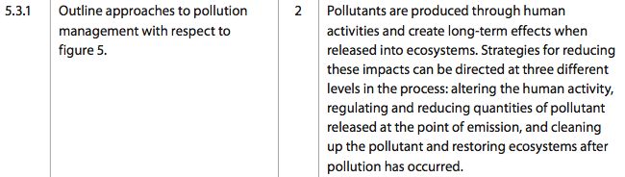
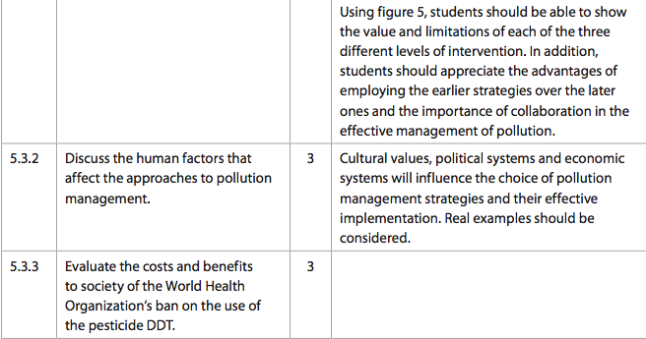
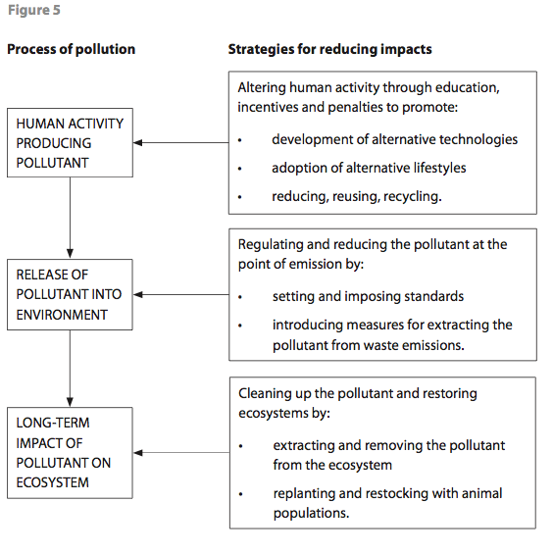

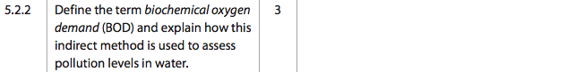

Resources

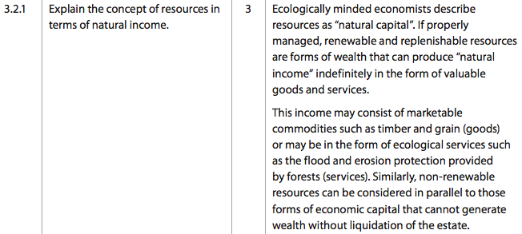

Ozone

